February | 2020

St Mark’s Presbyterian Church

Out of Many Nations, We Are One Family
The Celebration of Black History Month

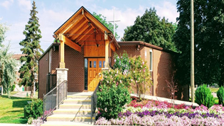
Sunday | Monday | Tuesday | Wednesday | Thursday | Friday | Saturday
 |  |  |  |  |  | 1
2 | 3 | 4 | 5 | 6 | 7 | 8
PWS&D Sunday  Worship & Communion 11:00 am  Sunday School and Nursery during worship |  |  | Kirk/Session meets @ 7:00 pm. | Bible Study on Revelation @ 6:30 pm
9 | 10 | 11 | 12 | 13 | 14 | 15
5th Sun. After Epiphany  Worship 11:00 am  Sunday School and Nursery during worship |  |  | Bible Study on Revelation @ 6:30 pm | Senior Choir Practice at 1:00 pm.
16 | 17 | 18 | 19 | 20 | 21 | 22
6th Sun. after Epiphany  Worship 11:00 am  Sunday School and Nursery during worship  Black History Month Luncheon |  |  | Bible Study on Revelation @ 6:30 pm | Senior Choir Practice at 1:00 pm.
23 | 24 | 25 | 26 | 27 | 28 | 29
Transfiguration  Worship 11:00 am  Sunday School and Nursery during worship |  | Pancake Supper @ 6:00 p.m. | Bible Study on Revelation @ 6:30 pm | Senior Choir Practice at 1:00 pm.
Planning an event in the Church?
Please check to be sure the space is available and to have it marked on the calendar.

